Java MultiThread

Thread Pool
- Can you describe your experience with multithreading in Java and how you handle concurrency issues?
- Briefly describe the processing flow of java thread pools？
- 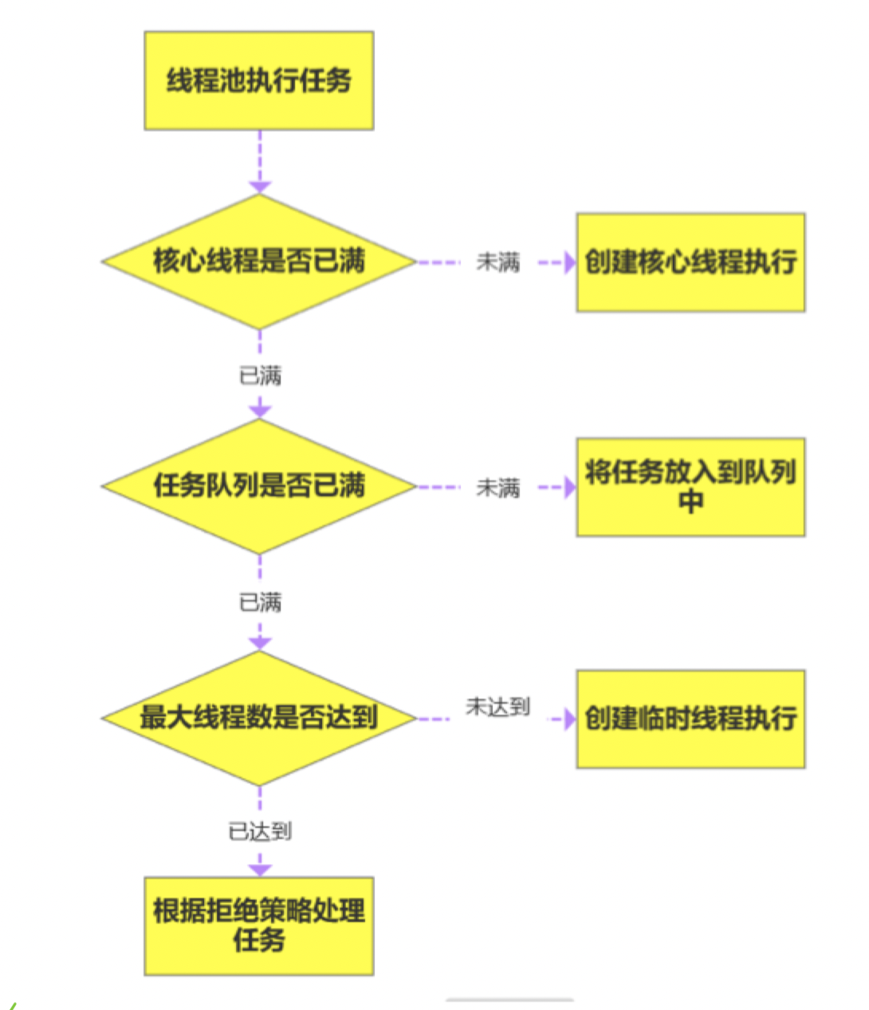
- Can you share something A related? Whatever you want.
- thread pool parameter：CorePoolSize MaxinumPoolSize KeepAlive
- ‌How many denial strategies are there for thread pools? What are each of them？
- 线程池的拒绝策略主要有四种：‌AbortPolicy、‌CallerRunsPolicy、‌DiscardOldestPolicy和‌DiscardPolicy。‌‌12

ThreadLocal
https://blog.csdn.net/u010445301/article/details/111322569
- It may lead to memory leaks, how to avoid

Kafka
https://1drv.ms/o/c/204f33561bc7cd38/EjjNxxtWM08ggCAXBQAAAAABaJfo-lDMABeT0j2f6O_FMw

Kafka structure
- can you briefly decribe for Kafka Architecture?
- Can you give a brief overview of the Kafka structure?
- 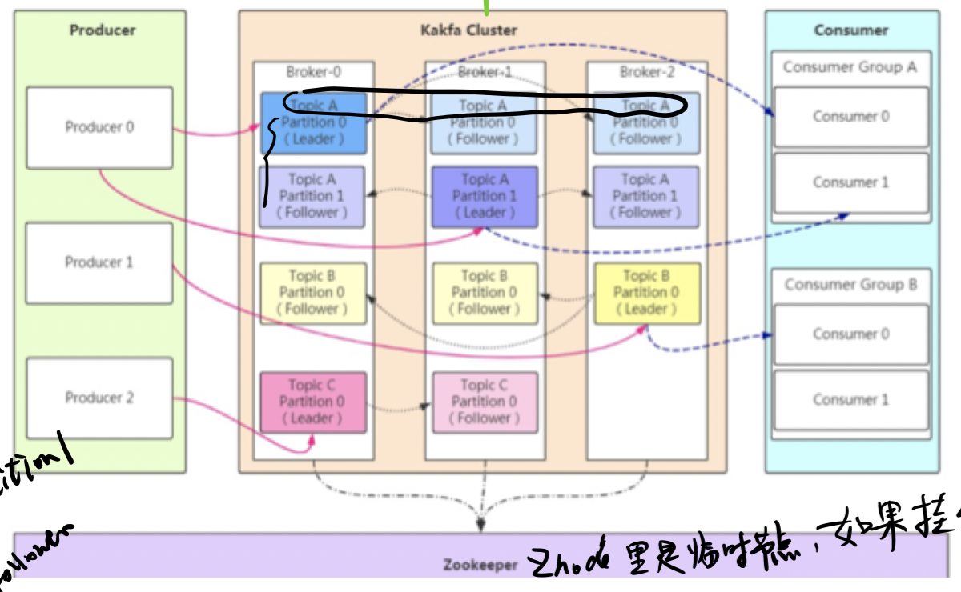

Kafka rebalance
- Do you know kafka rebalance? Can you briefly describe the kafka relalance process?
- When does it happen？
- How to deal with this issues
https://www.cnblogs.com/chanshuyi/p/kafka_rebalance_quick_guide.html

Kafka lose message
- In-Sync Replicas (ISR)
- When is Kafka likely to lose messages?
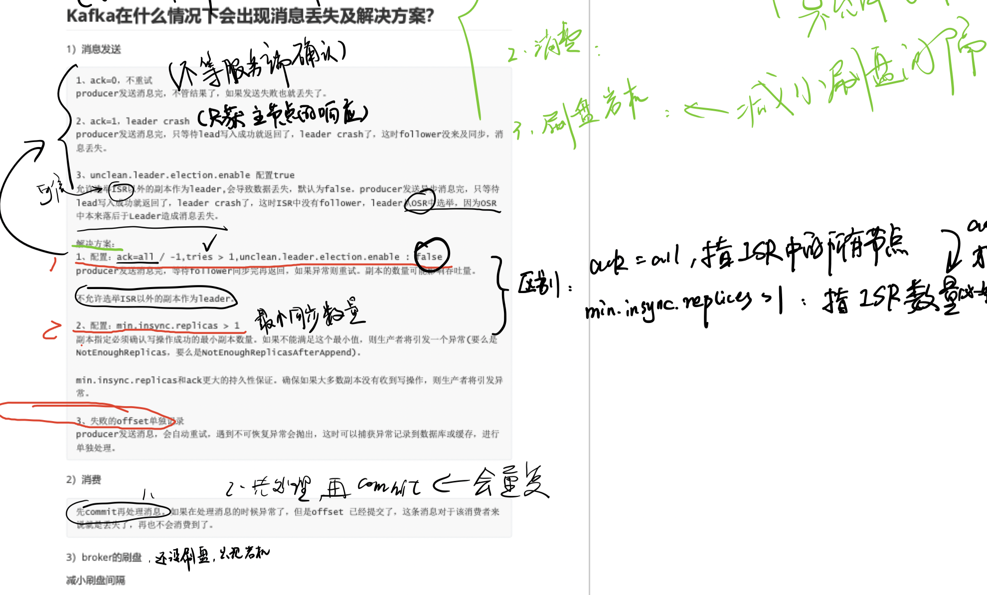

Spring Springboot

谈谈AOP，及实际应用

Spring 中用了哪些设计模式

Springboot 事物失效原因

What is the Difference @Component & @Service
- Have you ever used custom annotations?
- Explain Transation Management 【When does it not work?】
How did you implement in your application.
【getTransaction、commit、rollback】

- Explain Spring bean Life Cycle

SpringSecurity
- What is JWT Token？header payload、signature

Explain about Spring security
Explain how did you validate a user in your application
